College Tours for Students
IVY LEAGUE AND HBCU TOURS
The MTM Foundation sponsors college tours that allow aspiring college students to visit college campuses and receive an introduction to college life. Our tours are chaperoned by the Brothers of Alpha Phi Alpha Fraternity, Inc., teachers and parents. Our chaperones are certified in First-Aid/CPR and have undergone background investigations.

DURING THE TOURS
Students will receive a firsthand experience of what it is like to be on a college campus such as observing classes in session, eating at the dining hall, visiting the residence halls, speaking to current students and more.

TOURS INCLUDE WORK-SHOPS INCLUDE
ROUND TRIP FINANCIAL AID WORKSHOPS
MOTORCOACH TRANSPORTATION AVAILABLE SCHOLARHIPS/ENDOWMENTS

​MEALS AND LODGING APPLICATION PROCESS WORKSHOPS

​MEET COLLEGE COACHES/STAFF CAMPUS LIFE LESSONS

ON-CAMPUS ACTIVITIES TWO PARTICIPATION SCHOLARSHIP AWARDED

2018 COLLEGE TOURS

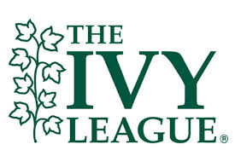
Brown University ● Columbia University ● Massachusetts Institute of Technology ● Princeton University ● Harvard University ● Yale University ● University of Pennsylvania, in addition: ● Pennsylvania State University ● Babson College

March 22-26, 2018
Depart Calvert Hall College at 9 am
Return to Calvert Hall College at 5 pm
$650
Payment plans available

Final payment is due by March 5, 2018
Medical Card Required
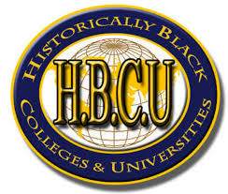
Delaware State University ● Bowie State University ● Howard University ● Hampton University ● Norfolk State University ● North Carolina Central University * Morgan State University ● North Carolina A&T University ● Clark Atlanta University ● Morehouse College ● Spelman College

March 27 to March 31, 2018
Depart Calvert Hall College at 7 am
Pick-up at Bowie State University at 8am

Return to Calvert Hall College March 31st at 9 pm(estimated)
$650
Payment plans available
Final payment is due by March 5, 2018
Medical Card Required

To register and for more information please visit our website
www.mtm1foundation.org
Mr. James Henderson 443-768-6939 or email: MTM1Foundation@gmail.com